Applications of Matrices – Linear Equations
Example of Solving Systems of Linear Equations: Matrices are used to represent systems of linear equations. The augmented matrix method and matrix inversion are common techniques.
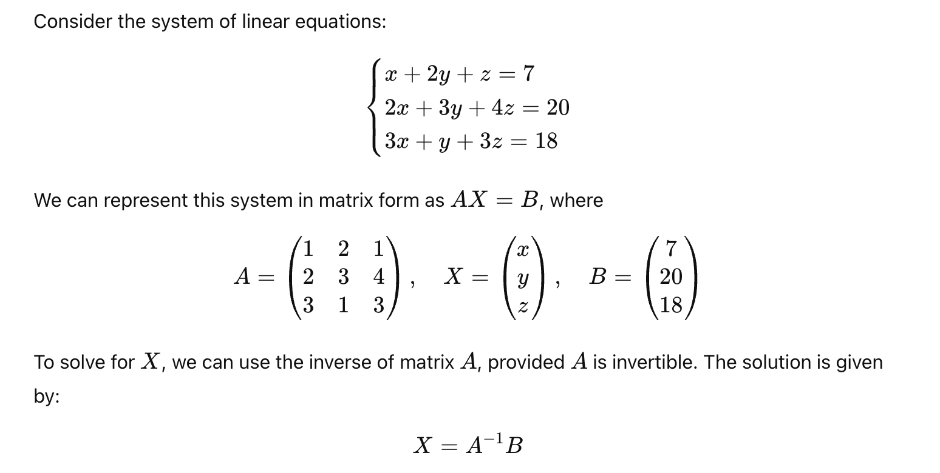

Step-by-Step Solution

